How to represent a Bayesian Network in the form of Markov Random Fields (MRF)? Explain them briefly using an example.

A markov random field is an undirected graphical model

* Undirected graph G = (V, E)
* One node for each random variable
* Potential function or “factor” associated with cliques, C, of the graph
* Non negative potential functions represent interactions and need not correspond to conditional probabilities.
* Correspond to a factorization of the joint distribution

**BNs vs. MRFs**

**Property** Factorization Conditional Distributions Potential Functions

**Bayesian networks**

**Markov random fields**

**Property Bayesian Networks MRF**

Factorization Conditional Distributions Potential Functions

Distribution Product of Conditional Normalized Product of Potentials Distributions

Cycles Not Allowed Allowed

Partition Function 1 Potentially NP-hard to Compute

Independence Test d-Separation Graph Separation

**MRF Examples:**

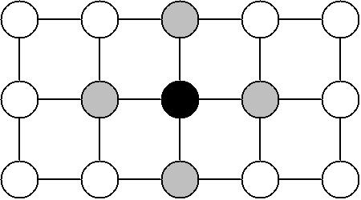

**Given the grey nodes, the black node is conditionally independent of all other nodes.**

From this point, "node" and "variable" shall be used interchangeably. x shall refer to a particular configuration of the set of the random variables. A subscript will denote a particular node or subset of nodes.

The Markov property tells us that the joint distribution of X is determined entirely by the local conditional distributions . But it is not clear how to actually construct the global joint distribution from these local functions. In order to do this, we need to look at Gibbs distributions.



where the product is over all maximal cliques in the graph. A clique is a subset of nodes in which every node is connected to every other node. A maximal clique is a clique which cannot be extended by the addition of another node. Z is called the partition function, and takes the form:



The  are usually written:



T is called the temperature, and is often taken to be 1. So  has the alternate form:



where



**MRF Applications To Vision**

1. Image restoration
2. Image reconstruction
3. Segmentation
4. Edge detection